***Elden Ring***

A Lost Hive

Cloud



Overview

* High puzzle, low fight
* Learn more about the original level on <https://www.bilibili.com/video/BV1we4y1s7wq>
* [关卡设计作业3第一人称解说_演示 (bilibili.com)](https://www.bilibili.com/video/BV1we4y1s7wq/) (strongly recommend)

Abilities

* Jump. About 0.5m tall and 2m far.
* Get no injury when jump from a high place, since the falling damage will appear from the height difference of 5m and the biggest height difference in this level is 4m.

Mechanics

* Red/Pink/Purple doors & Buttons: Mechanism doors, closed in the both side, keep open after hitting the button of the same color.
* Yellow doors: Destructible doors, closed from the both side, can be broke from any side, then keep open.
* Green doors: One-way door, lock from one side and can be open from another side, then keep open.
* Blue doors: Hidden doors, unseen from both side, keep open after being hit from any side.
* Gray doors: Normal doors, can be open from both side, then keep open. Especially, during the boss fight the normal door will keep closed until the boss dies or the player dies.
* Boss fight warning sign: just tell the player when you enter room the boss fight begins.
* Suicide device: the player will die after jumping into it.
* Portal: after touching the portals, player can shuttle back and forth from the rooms where two portals are.
* Stairs: go up and down. Player can go upon the top of the wall with the assistance of it.
* Chest: player will get some items and equipment from it. Some of them are traps, people will be transferred to another room after opening them. A chest will appear after defeating the boss.
* Transparent floor: Hidden floors, look like normal ground, but once player hit them or roll on them they will disappear.
* White and grey cones: close combat enemies and long-range enemies.
* Every time the player dies he will reborn in the beginning of the level and leave all his money where he dies. If he dies again before he pick his money he will lose all of them.

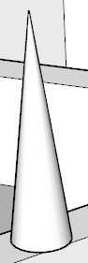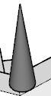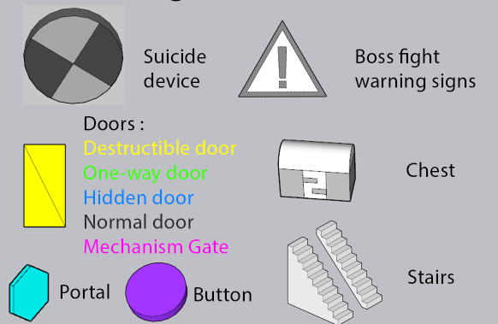

Close and long-range enemies

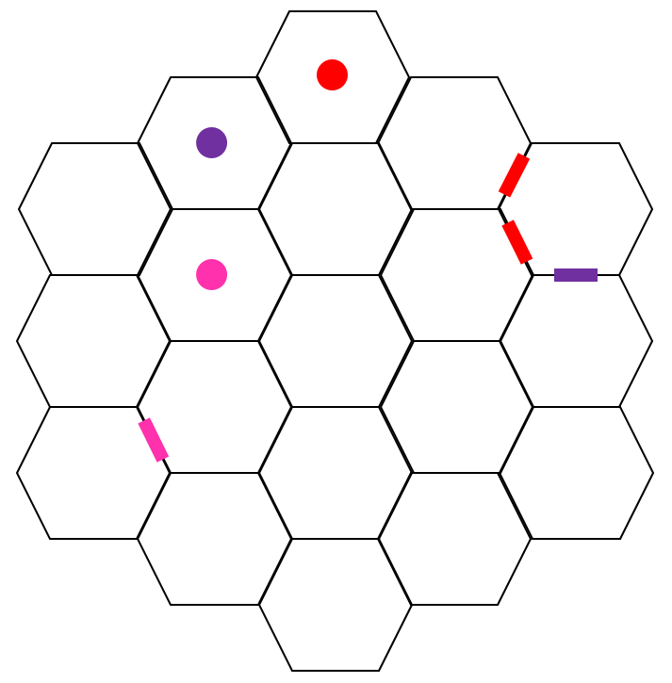

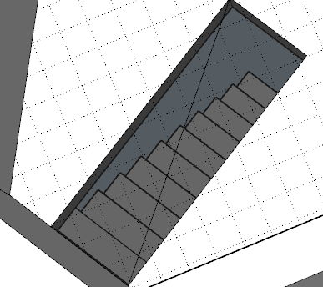

Map which player get in room 1

Hidden floor

Number of each room

Floor 1 above the ground

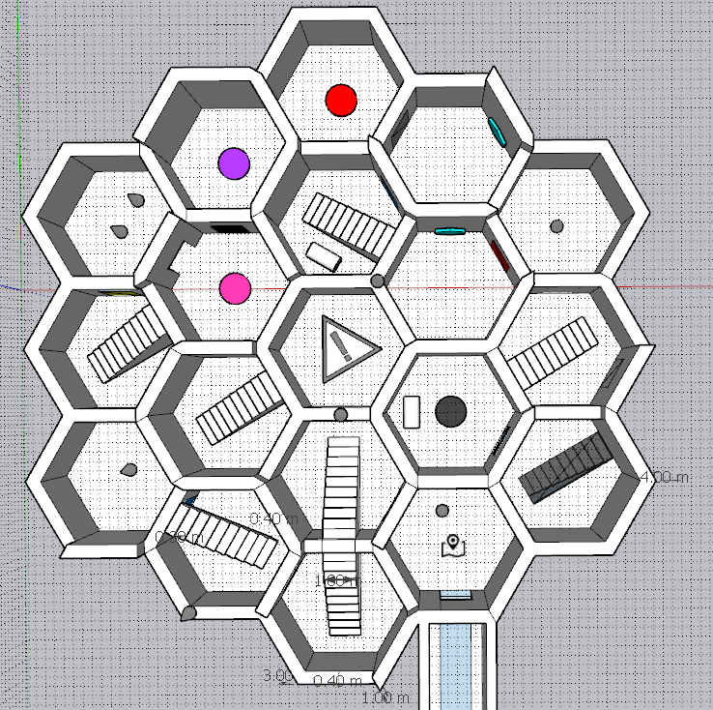

**15**

**2**

**18**

**17**

**0**

**1**

**4**

**5**

**6**

**3**

**19**

**16**

**14**

**13**

**11**

**12**

**10**

**9**

**8**

**7**

Floor 1 under the ground (Inverted view)

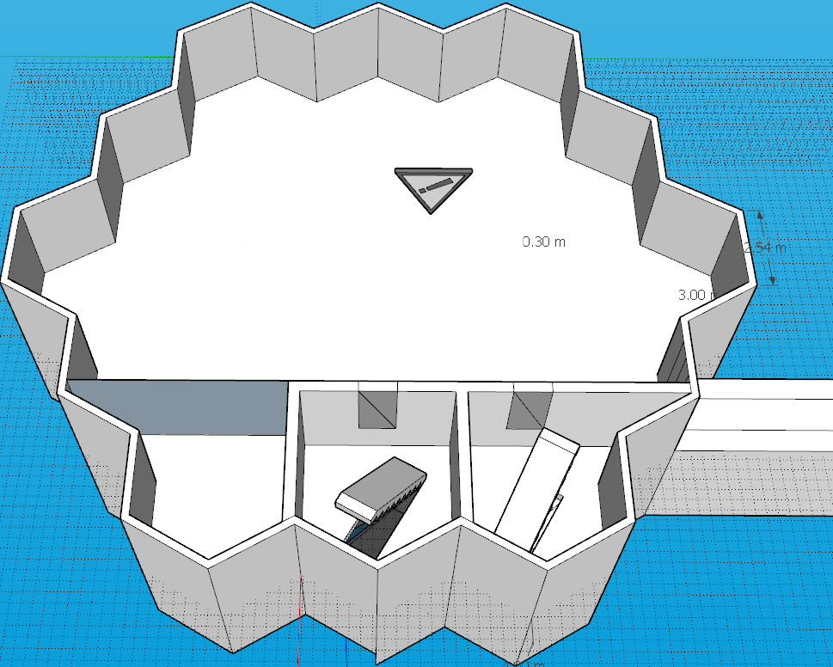

**20**

**18.1**

**17.1**

Level layout

* A common way to pass the level and collect all things is: 0→1→2→3→4→5→6→7→8→6→5→9→10→11→12→13→12→14→11→15→16→8→6→5→9→11→14→17→17.1→20→18.1→18→19→18→1→0
* Then I will explain each stages during the level, please read the follow with the help of the map

Overview

* The whole level is set in the sky, like a fire balloon, suspended in the air. This means if the player falls down from the edge he will die.
* Room 0 is a long corridor and offers a lot of use. One of them is to make this level easy to be connected with other scenes. Another use is to hide its full view from players. If players can see the whole level in the beginning even from the outside he will find it’s so deep and there may be a basement under the floor, that’s not I want. So I put a map in room 1 which only has a little information and the planar graph of the ground floor to give players some tips and also deceive them.

1→2→3→4

* Room 1&2 is mostly made for the player to suit the hexagonal room and the way to pass from room to room by the door.
* When travelling from room 2 to room 3, player will find that they can walk on the top of the wall which will be very helpful in the next rooms.
* Player will learn to pass the first door when moving from room 3 to room 4.
* When after passing the room 4, player firstly has the chance to move upon the top of the wall, along the whole level. Walking along the edge will provide the convenience to go back to room 1 or room 3 and provide a much broader vision for the player to overview the room besides him, even the rooms that will come, instead of being tapped in a little room and has no more sight than 6 walls.
* Also, player may notice the stair in room 4 is a little bit different from the stairs in room 2&3, and I hide a hidden wall downside the stair. Hope the player would find it and then he can go back to the room before.

5→6→7→8→6→5

* In room 5 player will meet a common design in puzzle games: an obstacle blocking the way, and the key to solve is somewhere else, in many games designers use this mechanism to make the game un-linear.
* Then I made a simple loop to make the player to find the button and go back to room 5. There’s a trick here but I want to keep it and explain later.

9→10

* During this stage player has nothing to do but go on the top of walls, through the levels and choose a room from 10, 11 and 15. Also he can go back to room 2 but that’s no help for exploring the level.
* The room player choose will be a very interesting thing, since he has a complete sight of these 3 rooms. If he is a player who likes fighting more he may choose to jump down to the room 15 to face the boss in priority, but that means he will lose the powerful equipment in the chest in room 10; if he chooses to go to room 11 first he still has the chance to open the chest before meeting the boss but that will take more time; so I decide to take the third way, go to room 10.

11→12→13→12→14→11

* At this stage player will do all he can do before the boss. Room 10 has a stair for player to go back upon the wall, and I will choose to keep explore, so here we are in room 11.
* As I said in the mechanics, the room 11 and room 12 are linked together by the portal, and you may notice that the settings of room 11&12 are totally the same (hidden door in room 12 is invisible), but they are not in the same direction at all. I made this to confuse the player. Also, player will clearly know that behind the normal door of room 11 is boss, so it may stop him from try to open the door of room 12. But, the red button is just behind the door.
* The room 14 is where I have mercy on players, once he find the red button he will find room 12&11 are adjacent to each other and has only 1 room between them. Then the rooms will not confuse him at all.
* After all these things, he will be blocked by the purple door and have nothing but to fight the boss.
* Also during this stage, if you happen to miss the room 10 and its chest and in the meantime you happen to find the hidden door in room 12, congratulations you will pick your reward.

15→16→8→6→5→9→11→14→17

* Let’s just imagine he defeat the boss in the first time. Then as the rule of the Elden Ring, a chest will appear, but, that would be a trap, just to transfer the player to a remote room: room 16. After I showing my level to my friends, one of them asked me ‘why do you frustrate the players after they trying hard to defeat the boss and send them to a non-meaning place’, and I just want to say, because this is *Elden Ring*, players often do not get what they deserve after fighting.
* Thankfully, the room 16 has a purple button and players now can open the one-way door and go back to room 14, move forward to the room 17

17→17.1→20→18.1→18→19→18→1

* Actually the boss I set in room 15 is a fake boss, who has very low HP and attack, and here we come the real boss.
* I set transparent floors in room 18 & 17, which is the entrance and exit of the underground floor. Room 17 has stairs to room 19, I will explain it later.
* The layout of the underground floor is very simple, just a big space to fight against the real boss and two rooms connected to the ground floor.
* Once the player defeats the boss and come back to the room 18, he will find the way to room 1 and room 19, then he can open the chest and finish the level.
* ?

18, 19, and 6

* Finally, I will introduce my most important trick in my level design.
* Room 19 seems like an unsuccessful and cruel design. The reward in the chest is very luxury but once you step in from room 17, you will have no way out. So considering the *Elden Ring* not support the manual archiving, to prevent the players from archive corruption I made a suicide device to help players go back to the beginning quickly. They may lose money but won’t lose the reward in the chest.
* You may notice on the wall of room 17&6, there’s a design like this: 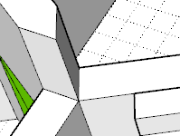
* There being a block not always means you can’t go through it. Remember you can jump. The distance the player can jump horizontally is about 2 meters, which is enough for the pkayer to jump over this 60° angel and get into the other side of the obstacle.
* This means the player could go to room 18 first and open two more doors: one to the room 1, and one to the room 19. Then the player doesn’t need to die after opening the chest.
* Let’s just change our focus back on room 6. I said before the player can choose when to fight the boss, also, he can choose whether to fight the boss. If he finds the trick the firt time he comes to room 6, somhow gets into the room 16, presses a confusing button, and decided not to fight the boss first, he will soon find he pass the level. That’s where Elden Ring is charming: you can choose your way and the enemies, non-linear and few objective-oriented.
* So here is the shortest road to pass the level: 1→2→3→4→5→6→16→8→7→8→6→5→9→11→12→13→12→14→17→18→19→18→1

It’s much shorter than before and by this player can get all chests except for the real boss reward.

Flow Chart

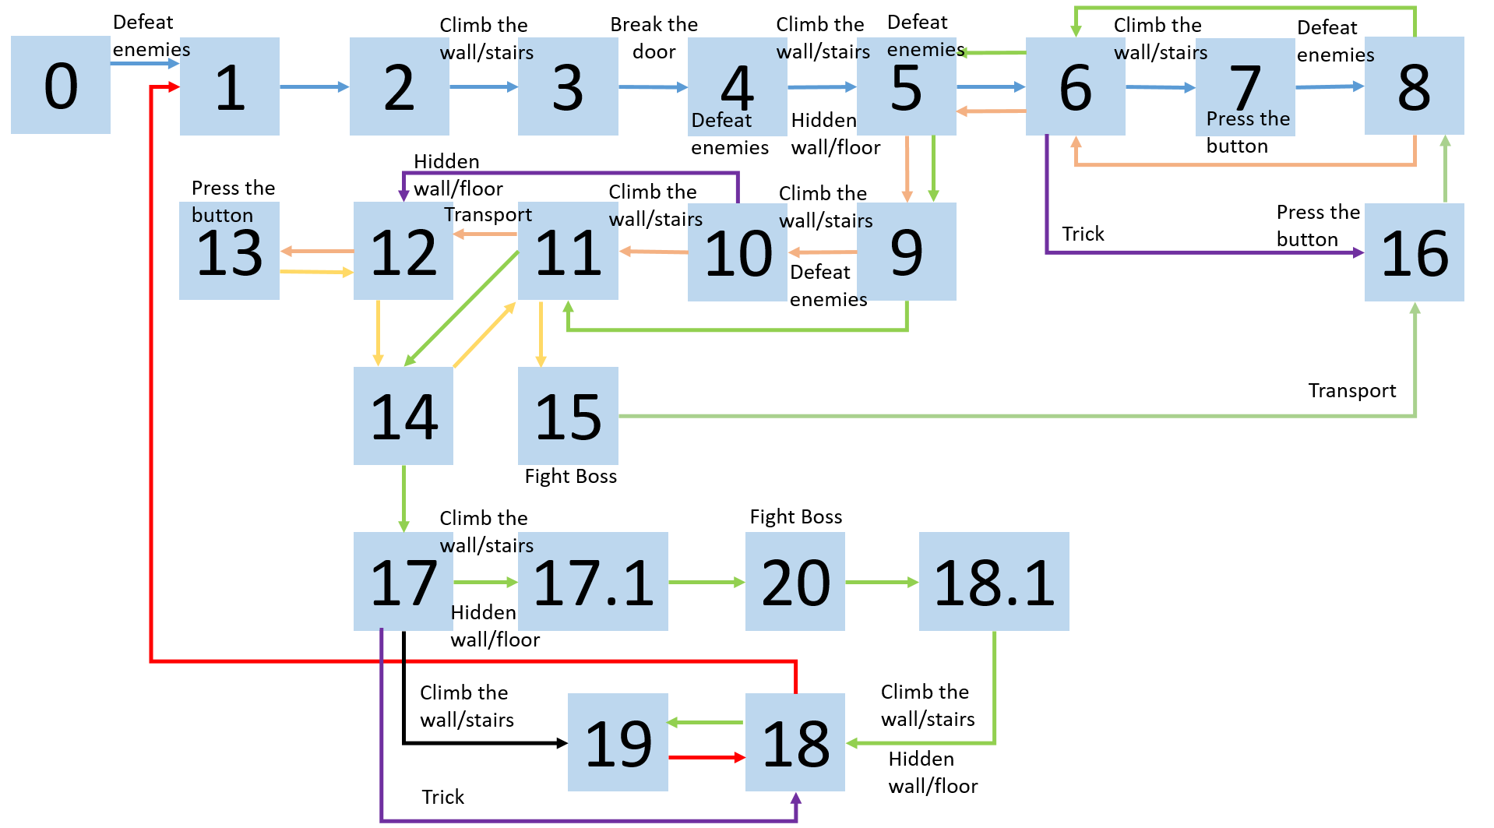

Asset

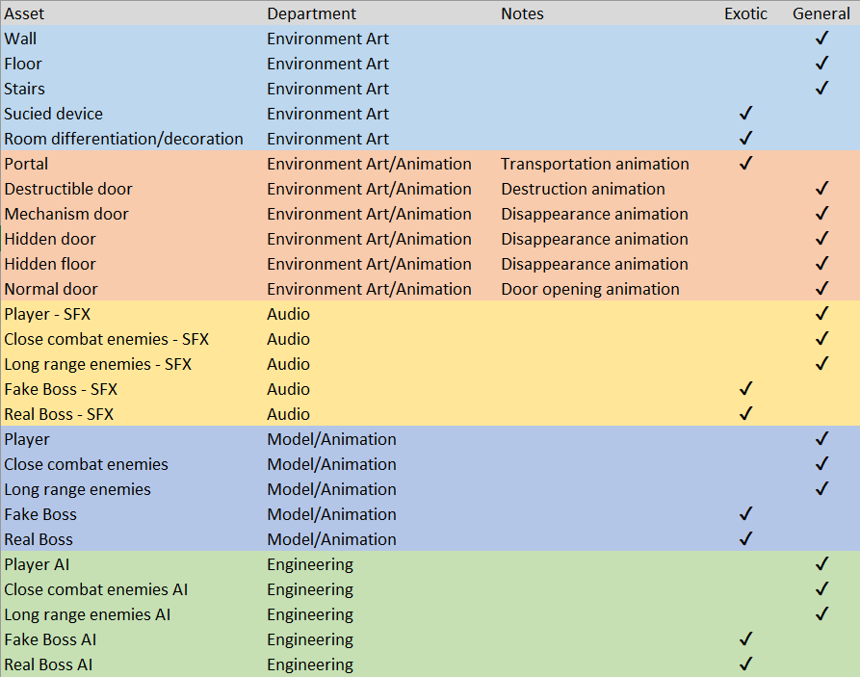

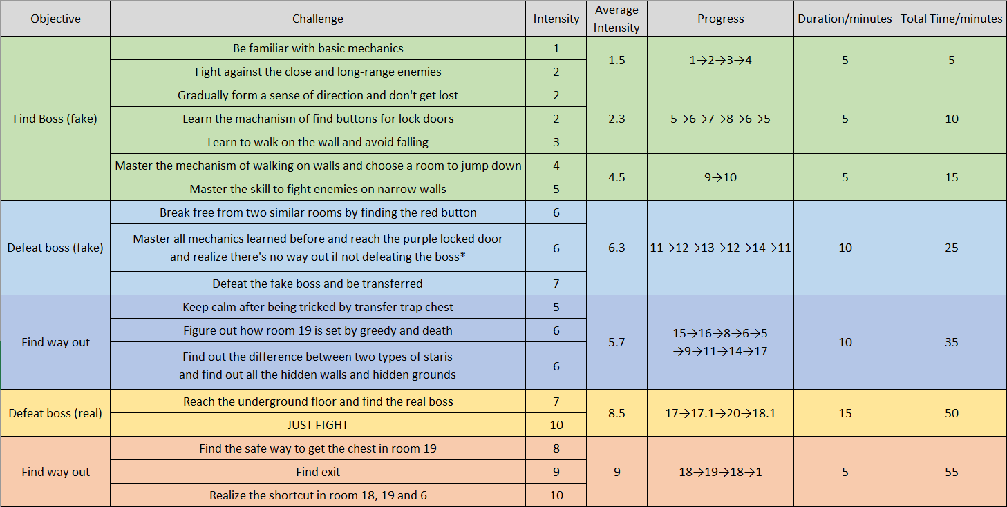Beat chart